Chapter 5
BEHAVIORAL SUPPORT PLAN
Objectives:
- To understand the components of the Behavioral Support Plan.
- To develop an understanding of how to enter the Behavioral Support Plan in the Home and Community Services Information System (HCSIS).

WHAT IS A BEHAVIORAL SUPPORT PLAN?
Please note that the information contained within this chapter might be helpful to share with members of the team or direct care staff when the Behavioral Specialist is doing training and consultation.
As previously mentioned (in Chapter 4), the Functional Behavioral Assessment (FBA) drives the Behavioral Support Plan (BSP). Understanding all variables (including the function) that maintain, promote, or increase a behavior helps determine what components need to be eliminated, presented, or maintained to ensure positive behavior in the future. All BSPs should include many components that address the short term and long-term needs of the participant. Ask yourself, “What changes can I make to the participant’s immediate environment that will address the variables that promote, increase, and maintain the behavior?” And, “what skills does the participant need to get their needs met in a more understood, acceptable manner?”
The Behavioral Specialist will have 60 days from authorization of Behavioral Specialist Services to complete the FBA, BSP, and Crisis Intervention Plan (CIP). The following guidelines outlined in this chapter and Chapter 6 (CIP) will be important tools for this process. Additional resources can be found in Appendices A through D.
The following outlines a multi-component BSP plan, taking into consideration antecedent and setting event interventions, teaching new alternative/replacement skills, consequence interventions, and lifestyle interventions and Long Term Supports. The interventions listed are general suggestions for how to develop a BSP for the participant you are supporting. Individualization of the plan will be required to meet his/her needs. A sample BSP can be found in Appendix C.
Setting Event Interventions
Setting event interventions help eliminate the slow triggers that may cause challenging behaviors to occur. Setting events may set up how a participant’s day unfolds, which may trigger additional challenges throughout the day. For example, if Brian comes into work hungry, it may contribute to his attention to task at work. However, if those setting events are addressed, it may reduce the chances for a challenging behavior to occur. An example of an appropriate setting event intervention for Brian’s situation would be to offer a snack mid-morning instead of waiting until lunchtime. This would provide a natural break in his workday and address the hunger; therefore, there is a decreased chance that challenging behaviors would occur.
Additional examples of setting event interventions include:
- Allow for a short rest or break halfway through the workday to address sleep issues.
- Use social stories to teach social skills and address difficult or confusing situations.
- Give advance warnings to schedule changes to prepare the participant before a change occurs.
- Use earplugs or work in a quieter room to address noise sensitivity issues.
- Rehearse or role-play situations, such as doctors’ appointments, to reduce anxiety.
- Take an alternate route to work if the participant has difficulty with stop and go traffic or benefits from a more direct route.
- Adjust room temperature when participant is sensitive to the heat or cold.
Often, setting event interventions require the team to think “outside the box” and manipulate, eliminate or modify several things within the participant’s environment at home, work, or in community settings that may “set the stage” for challenging behavior.
Antecedent Interventions
Antecedent interventions help to eliminate the fast triggers that cause challenging behaviors to occur. Similar to setting event interventions, antecedent interventions are put into place before a challenging behavior occurs. Often, they require the staff person or family member to introduce activities differently, schedule events in the participant’s day according to preference, or to make modifications to the participant’s environment. When used and taught appropriately and effectively, the probability of the challenging behavior occurring decreases.
Examples of Antecedent Interventions include:
- Put non-preferred activities at the beginning of the day so the participant does not have to complete them at the end of the day.
- Give participant a choice in order of task completion to build self-determination.
- Alternate preferred and non-preferred activities within the participant’s day to build motivation and encourage completion of all tasks and demands.
- Give warning notices or preview activities to prepare for changes within the participant’s day.
- Offer frequent breaks in between activities to reduce frustration levels with activities.
- Alter tone of voice when delivering requests to address issues with delivery of requests.
- Modify length of tasks to meet participant’s attention capacity.
- Involve participant in meal scheduling and meal choices to build self-determination.
- Provide participant with positive feedback for good performance/task completion as an alternative to attention-seeking behavior.

Replacement or Alternative Skills Instruction
Another part of the behavior support plan involves alternative/replacement skills instruction. It is important that these alternative or replacement behaviors are just as effective, efficient, and relevant as the function of the challenging behaviors. For example, if a participant has difficulty communicating that they need a break from their work, it may be appropriate to teach him/her to use a “break” card that is readily available and understood by the participant (efficient). This card would be given to a staff member to illustrate that need. The break card serves the same function as engaging in the challenging behavior, but the break card is a more appropriate way of communicating a need to another person (relevant).
If alternative or replacement skills are not taught, then he/she may resort back to the behaviors of concern or learn new challenging behaviors to get his/her needs met. The skills should be taught in the actual settings where the skill will be used, while encouraging generalization across different settings and situations. Also, different support staff should practice the new skill with the participant so that the skill will be performed with many people, as well as in many settings.
When the participant uses the alternative/replacement skill (with or without prompting), he/she should have that request honored in an effort to reinforce the participant immediately, encouraging future use of the alternative/replacement skill. This new behavior should decrease the need to engage in the challenging behavior (effective).
There are several categories of alternative/replacement skills that could be considered when determining what to teach the participant
The first category is communication skills. If the participant is not able to communicate his/her wants and needs to another person in a way that is appropriate, then challenging behaviors are most likely to occur. Communication skills are one of the most important areas to identify and teach first. An example of a communication strategy is teaching the participant to use pictures to communicate.
The second category is self-monitoring skills. As an adult, the participant should learn to assess his/her own behavior to then make independent decisions about what to do next. An example of a self-monitoring strategy would be to teach the participant to collect data on their socially inappropriate behavior in the workplace as a means to make the participant aware of the behavior and to encourage them to be an active participant in behavior change.
The third category is teaching coping skills, which focuses on strategies for when the participant becomes upset or frustrated. For example, teaching the participant to identify a potentially problematic situation and a specific set of actions to deal with the situation (e.g., go to another room, deep breathing, etc.) would be an example of a coping skills strategy.
A fourth strategy would be general life skills. These skills may assist the participant to be more independent with getting ready for work, finding pleasurable activities to engage in, and proper health and wellness education to increase his/her quality of life. For example, teaching a participant to appropriately use the ATM machine may increase independent/self sufficient skills, while decreasing confusion and any behaviors of concern.
The final category involves social skills. Teaching social skills to the participant will help develop positive interactions that are meaningful. With appropriate learned social skills, the participant will build independence and confidence to make and keep new friends in the home, workplace, and in social community settings. The following highlights specific skills under the five general categories that can be taught to the participant.
- Communication skills- Several strategies to teach communication skills include the participant verbally saying a short word or phrase that depicts a request that is common to society (e.g., saying the word “help” would be clear in letting someone know that you need help). However, depending on the participant’s verbal abilities, other communication skills include using pictures or objects to physically show someone what is needed, using sign language, or using an alternative communication tool to express a need. Most importantly, the participant should be taught a communication skill that is equivalent to the challenging behavior to meet the same function.

- Self-monitoring skills- This category involves teaching the participant to identify triggers or situations that may be problematic and how to work through them. Examples include teaching the participant to use a checklist to remind him/her of what to do next, while keeping track of what has already been completed. It may also be useful to teach the participant to recognize when he/she is becoming agitated or upset, and how to use strategies (e.g., go for a walk, take a break, get a drink) independently.
- Coping skills- This strategy is similar to self-monitoring skills because you are teaching the participant how to deal with difficult situations by incorporating meaningful and age-appropriate strategies instead of engaging in the challenging behaviors. It may include taking 10 deep breaths, asking to go for a walk or get fresh air, squeezing a stress ball that is in his/her work desk, talking to a support staff, or getting a drink. These coping skills should be quick and easy to access so that the person can use the skill and then return to work or the activity quickly.
- General life skills- Life skills are a critical element for the participant’s well being as an adult. Proper eating and hygiene skills should be taught so that he/she can begin to make independent decisions about their lifestyle. Setting up a morning or evening routine will begin to develop that independence. If the participant takes a bus or other means of public transportation, then they should be taught how to read the map, find the closest bus or train stop, and know what time to leave the house. This category may also include safety skills (e.g., stranger awareness, crossing the street). If the participant enjoys a cup of coffee in the morning and usually gets one on the way to work, teaching the participant to prepare his/her coffee or ordering from a menu are important life skills that will increase independence and overall quality of life.
- Social skills- Developing a positive social life with other individuals in home, work, or community settings is important for an adult’s well-being and social acceptance. Most adults would prefer to engage in social situations without a support staff or another family member present. Therefore, teaching social skills will build independence and self-confidence, giving the participant a chance to engage with other individuals in natural social settings. Examples of social skills include teaching the participant how to begin a conversation, how to maintain a conversation with another person, and how to end a conversation. It can also be useful to teach the participant how to choose a social outing independently or how to listen and respond to the other person.
When deciding what skills to teach the participant, skill deficits should be the immediate focus and most importantly, an evaluation of communication skills. If the participant does not have an effective means for communicating, then it will be difficult to embed additional skills. And, remember, behavior is a means of communicating one’s needs. Note that while the participant may have adequate language skills (e.g., good vocabulary, etc.), their ability to communicate their wants or needs, especially in anxiety provoking situations, may be limited.
How do you teach alternative/replacement skills?
Once you decide what to teach the participant, understanding how to teach the skill is equally important. Ultimately, teaching the skill is similar to writing a lesson plan:
- Identify the outcome or ultimate objective of the skill (e.g., should the participant learn to do this skill independently or with some assistance?).
- Identify where the skill will be taught (e.g., home, work, or community settings).
- Identify what prompts will be used to teach the skill (e.g., most to least, verbal, physical) and how prompts will be faded over time.
- Identify what reinforcements will be used to increase the future use of the skill (e.g., additional leisure time or community outings).
Most importantly, staying organized, focused, and motivated while teaching the alternative/replacement skill will increase the overall success of the skill acquisition.
Consequence Interventions
Consequence strategies involve the way others react to a behavior, whether it is the behavior of concern or the replacement behavior. When using consequence interventions, they should be faded appropriately, with a focus on more natural consequences to behavior (e.g., co-workers’ praise, neighbors acknowledging the participant, etc.).
Consequence strategies that reinforce the replacement behaviors: There are three general categories to consider when identifying an appropriate consequence. They include:
- Rate (how often the reinforcement should be given)
- Immediacy (how soon after the behavior is performed the participant will receive the reinforcement)
- Quality (how preferred the reinforcement is or how much of the reinforcement should be given before the participant becomes bored with it).
There are several types of reinforcements including tangibles (food, drink, new CDs), activities (free time, music time, trip to the movies or the mall), and social reinforcement (high five, pat on the back, “good job!”). Regardless of the reinforcement, it is important to understand what is appropriate for the participant’s age, socially acceptable, and considerate of his/her current functional skills. What may have been appropriate for a high school student may look socially stigmatizing for an adult. For example, giving stickers or candy as a reinforcement for appropriate behavior in a Math class may not be appropriate or acceptable at the participant’s workplace in a community setting.
Consequence strategies to decrease challenging behaviors: When challenging behaviors occur, it is important to identify the consequences that will be used to reduce the challenging behavior from occurring again. Historically, the use of punishment (e.g., aversives) has been used to decrease the behaviors. However, it is understood today that aversives will not be used. Instead, typical consequence strategies to decrease challenging behaviors include withholding the reinforcement that was used to promote positive behavior. The conclusive result would be that withholding the reinforcement would have a punishing effect on the challenging behavior, making it less effective and efficient than the replacement behavior. For example, the participant may receive monetary compensation for each part of their work assignment completed. However, if a behavior of concern occurred, then the participant would not earn monetary compensation for that specific part of the task.
There are times, however, when a behavior of concern escalates into more severe behavior, or crisis. The next chapter (Chapter 6), Crisis Intervention Plan, articulates the components of an effective crisis plan keeping respect for the individual at its forefront.
When considering an appropriate consequence intervention, the ISP team should discuss the following questions:
  - What reinforcers are available for appropriate or alternative behavior?
  - What is maintaining the target behavior?
  - What are the local norms for reinforcers?
  - What is acceptable in this environment?
  - What is acceptable to the people in the environment (social validity)?
  - Are there other, more appropriate behaviors that will get the need met?
  - How do same age peers get the need met?
  - How long can the intervention continue?
  - Can you provide the intervention to more than the participant?
  - Can you maintain this intervention?
Lifestyle Intervention and Long-term Supports
The last part of the BSP involves consideration for the participant’s lifestyle and quality of life. If people are satisfied with their daily activities, who they live with, how they spend free or personal time, and what choices they have throughout their lifetime, then they tend to have a positive quality of life. For the individuals who engage in challenging behaviors, it is sometimes difficult to achieve a positive quality of life on his/her own due to isolation, not being accepted in the community. Five important lifestyle factors will develop healthy long-term supports for the participant:
- Choice- Individuals with disabilities are often given limited or no opportunities to make choices within his/her day. Simple choices such as what to eat, when to go to sleep, what leisure activities to engage in, where to work, or with whom they want to establish relationships are the common areas where choices are not offered; however, we also need to consider more involved decisions in which participant choice can be infused (e.g., roommate selection, job placement, etc.) As a team, consider the following when deciding how to increase choice opportunities throughout the participant’s day:
- How often, with whom, and where does the participant have opportunities to make choices?
- How does the participant’s daily schedule reflect personal interest or preferences?
- How much say does the participant have in day-to-day choices in home, work, and community settings?
- Community Inclusion- As mentioned in Chapter 3 (Positive Behavior Supports) community inclusion is important for the participant to develop self-reliance and a positive quality of life. Consider the following when deciding how to infuse community inclusion opportunities throughout the participant’s day:
- To what extent is the participant included in typical community activities?
- What age-appropriate community activities does the participant participate in?
- Relationships- With an increased awareness of including the participant in community settings, building meaningful relationships with other people is equally important. However, simply being in an inclusive environment does not always mean that the participant has developed meaningful relationships. Consider the following:
- To what extent does the participant have healthy meaningful relationships with other same-age peers?
- How can we promote opportunities to develop healthy meaningful relationships for the participant in community and recreational settings?
- Valued Roles- Often when participants are in work or community settings, they are not viewed as valuable members of the group. It is the job of the team to identify how the participant can develop valued roles to have a sense of belonging and reduce negative perceptions. Consider the following:
- Are there areas within home, work, and community settings where the participant can make a meaningful contribution?
- Are there specific responsibilities that the participant can assume in home, work, and community settings?
- General Health and Well-Being- The team needs to discuss several health and well being concerns so that safe environments can be established throughout the participant’s life. For example:
- Are there short- or long-term health issues that need to be addressed?
- How will the team know whether the participant is pleased with life?
- How can the team promote a safe environment for the participant in home, work, and community settings?
Finally, to ensure that the strategies developed in the BSP are maintained throughout the participant’s daily life, specific strategies to sustain support should be developed. What will the team do to ensure that this plan will be used across settings and over time? How will new direct staff and others in the participant’s life know about and be able to use the BSP? The answer to these questions relates to training and awareness. The Behavior Specialist will need to train all stakeholders on specific strategies to ensure consistent support across all settings between the BS and the SC, they should keep team members/providers/others aware of changes in the BSP, and those others need to keep the BS and SC aware of changes that require revisions to the BSP.
The following chart illustrates the four parts of a multi-component intervention plan. This chart can be used for the team to brainstorm what the BSP should look like for the participant.

Antecedent/  Setting Event Interventions | Alternative Skills Instruction | Consequence Interventions for Problem Behavior and Alternative Skills | Lifestyle Intervention and Long-term Supports
Modify OR eliminate stressors  Introduce positive elements | Communication skills  Self-monitoring skills  Coping/tolerance skills  General-life skills  Social Skills | Reduce outcomes  Provide instructive feedback  Develop crisis management plan | Make lifestyle changes to increase quality of life  Strategies to sustain support

TRAINING ALL STAKEHOLDERS IN IMPLEMENTING THE BEHAVIOR SUPPORT PLAN
Once the BSP is created, the next step is to begin implementation. In order for the BSP to be effective, all stakeholders must be trained. It is the role of the behavioral specialist to train the team on all components of the BSP. Although it is not required, it may be appropriate to reconvene the support team to provide training on all parts of the BSP. It is the role of the Behavioral Specialist to ensure that all team members and all others who regularly have direct contact with the participant are fluent on the implementation of the BSP. If a team meeting is held, but all providers are not present, the Behavioral Specialist must provide face-to-face training for those providers at a near future time convenient for both parties.
- Get to know the participant- All stakeholders supporting the participant should take the time to get to know the participant. A rapport needs to be developed before a BSP can be implemented appropriately.
- Encourage team members to ask questions- Before implementing the BSP, the Behavioral Specialist should solicit questions and provide thorough answers to address any concerns with the BSP. Often, people are hesitant to ask questions, but this step is important to ensure all team members are on the same page. The Behavioral Specialist may also want to role-play specific situations the team may face and brainstorm as a team what should be done. The team should feel comfortable implementing all parts of the plan but it requires frequent communication, trust, and understanding with all members of the team.
- Provide check-ins- The Behavior Specialist will work with the various providers and direct care staff on how the BSP should be implemented. The BS would monitor on site how the BSP is being implemented, request data collection and provide forms for that purpose, analyze the data and share results as appropriate. The BS would also keep the participant, representative, family and SC informed about concerns, changes, etc. as appropriate and provide consultation and training to those as well as the direct care staff/providers as needed.
- Provide feedback- Similar to checking-in with the entire team, the Behavioral Specialist should provide feedback by going out into the field, observing the plan being implemented, and discussing observations with the specific providers.

THE BEHAVIOR SUPPORT PLAN IS DEVELOPED, WHAT IS THE NEXT STEP?
The Behavioral Specialist will ensure that all members of the participant’s team are trained on the implementation of the BSP/CIP and have a paper copy of the plan. In addition to the paper copy of the BSP/CIP, the Behavioral Specialist is responsible for entering the BSP/CIP in the Home and Community Services Information System (HCSIS). For additional information on HCSIS, refer to Chapter 7. The BSP/CIP is a subsection of the Individual Support Plan (ISP), which is housed in HCSIS. The Supports Coordinator has the sole responsibility for creating the ISP in HCSIS; therefore, the Behavioral Specialist cannot enter the BSP/CIP until they have received notification from the Supports Coordinator that the ISP has been created in HCSIS*
*Until further notice, the Behavioral Specialist will complete an interim word document containing the specific screens of the BSP as depicted in HCSIS (See Appendix D). Upon completion of the document, it will be submitted to BAS for review, which will then be submitted to the Supports Coordinator, who will enter the BSP/CIP into HCSIS.
HOW DO I ENTER THE BEHAVIOR SUPPORT PLAN IN HCSIS?
Before you can log on to HCSIS, you must obtain a user ID and password from your HCSIS Administrator. Once you have obtained a user ID and password, you can access HCSIS through your web browser.
- Enter the HCSIS Internet address (https://www.hcsis.state.pa.us) in your web browser’s address line and then select the HCSIS link. The login page will then appear. Enter your user ID and password and click Login.

- You will then arrive at the HCSIS Home Page. From the Home Page, you can navigate to a subsystem within HCSIS by using the menu navigation links near the top of the page. For purposes of entering the BSP, click the navigation link to the Plan, Manage Plan, then to the third level navigation bar and click Manage Plan.
- The Individual Search screen allows the user to search for a participant in the system. This is the first screen that allows the user to create, revise, or view a plan depending on the participant’s plan status. In the example below, the user searched by last name. The user will then click the link to the participant for whom they are searching.

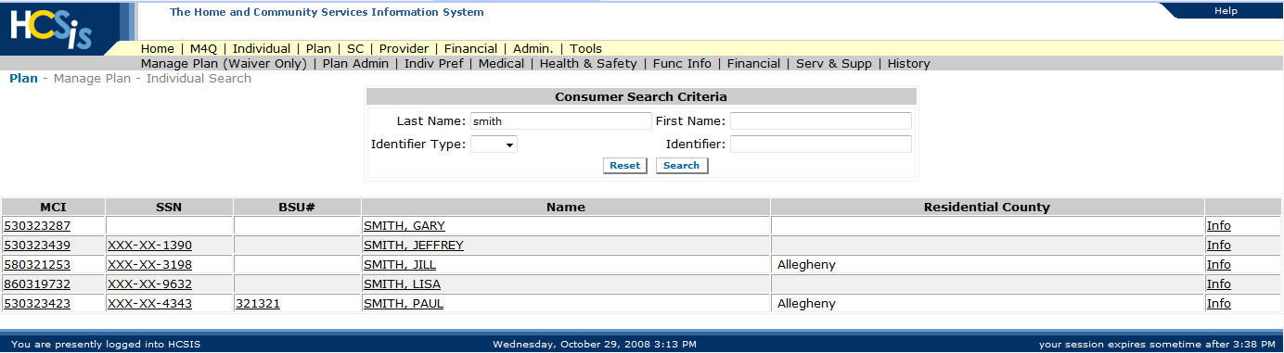

- Since the Supports Coordinator has already created a Plan for the individual, the Manage Plan Main Menu will give you three options: View/Modify Plan Details, View Plan History or Print Plan. Select the link to View/Modify Plan.

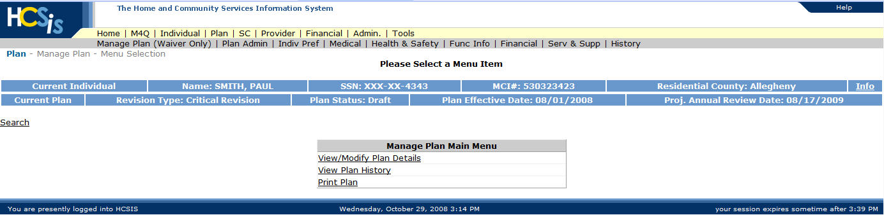

- The View/Modify Plan Details link will take the user to the View Plan Details screen. This screen displays the Plan information with important dates and the links for navigating to the different sections of the Plan.

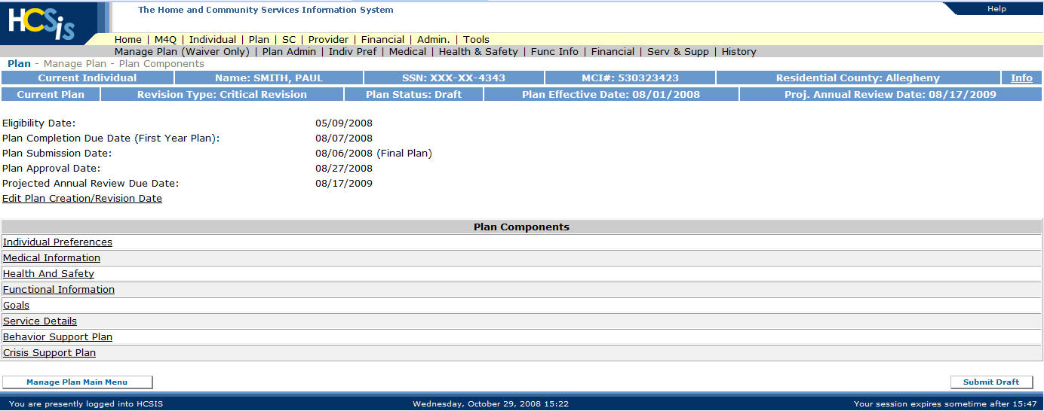

- From the Plan Component screen, click the link to Behavioral Support Plan. The Behavioral Support Plan in HCSIS contains multiple sections that must be completed. The first section allows the user to enter one or multiple desired behavioral outcomes. From the first screen below, click the “add” button.

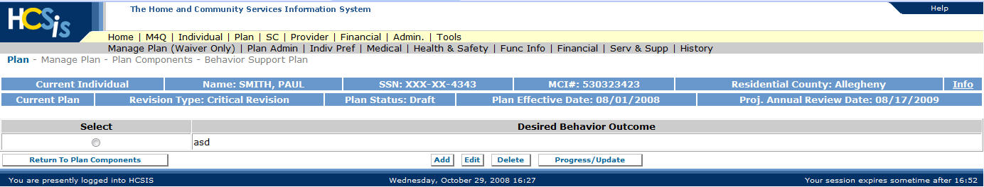

The screen below will allow the user to capture information on the hypothesis (condition, behavior, and function of the behavior) and the specific behavioral outcome written in observable and measurable terms (condition, behavior and criteria). Once this screen is complete, click the save and continue button. The desired behavioral outcome will now appear on the screen seen above. The user may enter additional behavioral outcomes by clicking the “add” button and completing the components to each of the added outcomes.

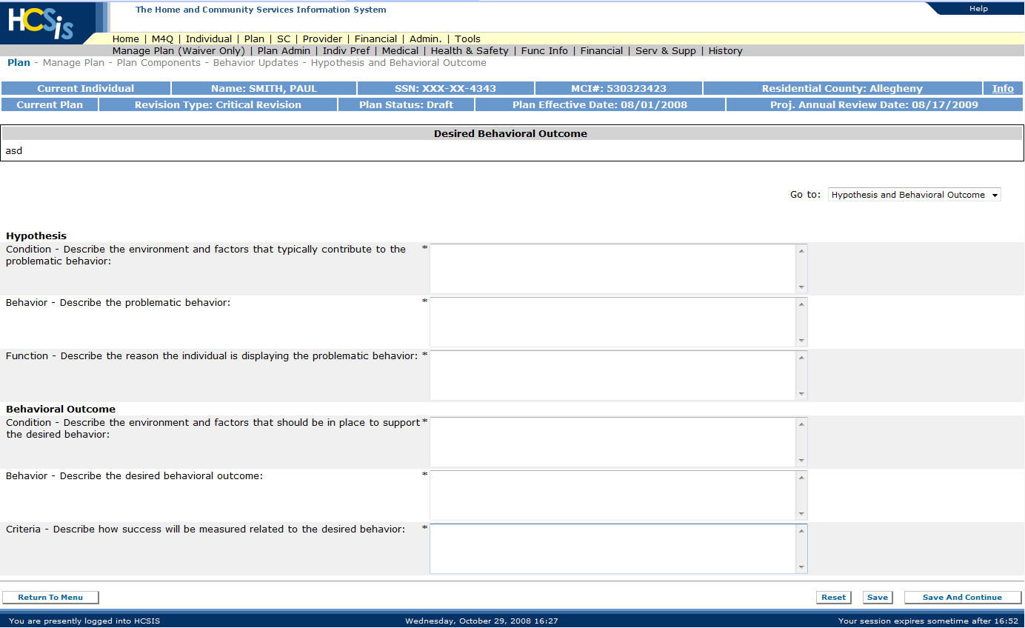

- The Behavior Supports Plan – Strategies screen allows the user to capture strategies designed to prevent or decrease the likelihood that the challenging behavior will occur and strategies that will increase the likelihood that the desired behavior will occur. If the participant has multiple behavioral outcomes, the user must select the behavioral outcome for which they are entering strategies. The strategies screen includes information on the following:
- Antecedent strategies – methods to prevent or avoid challenging behavior
- Replacement or alternative strategies – methods to replace or teach alternatives to the challenging behavior
- Consequences – methods designed to reinforce the desired behavior

Below is a sample screenshot for the Behavior Support Plan – Strategies screen.

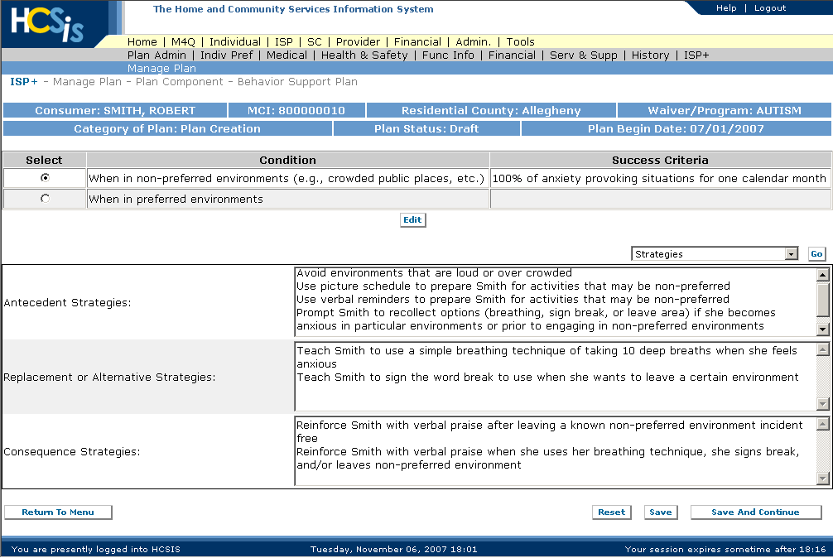

The Behavioral Support Plan – Means of Monitoring screen allows the user to capture Means of Monitoring for each behavioral outcome. In this screen the user must describe the behavior for which data is being collected, the type of measurement, and the frequency of data consolidation.

Below is a sample Means of Monitoring screenshot.

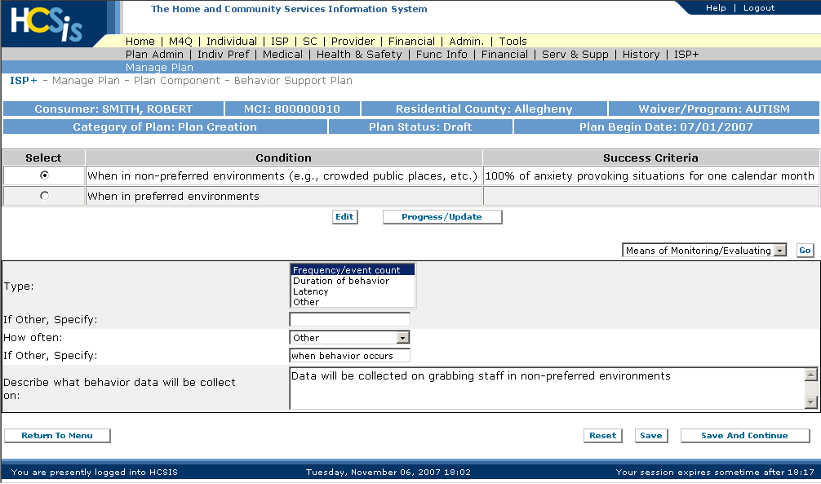

- The user can enter progress information on each outcome by selecting an outcome and clicking the Progress/Update link. In this screen the user can add activities that are being tracked, the trend for each of the activity, and record overall comments. Multiple variables can be tracked by clicking the “add” button.

Below is a sample screenshot for the Behavioral Support Plan – Behavior Progress/Update
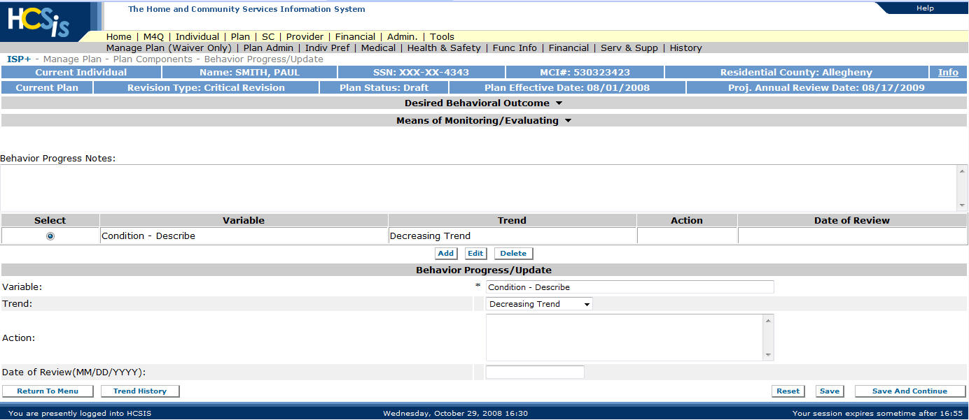

- The final screen available to the user in the Progress/Update section is the Trend History screen. For the selected variable, the user clicks the Trend History link on the bottom left side of the screen. This screen will summarize progress/trend information entered from previous reviews.
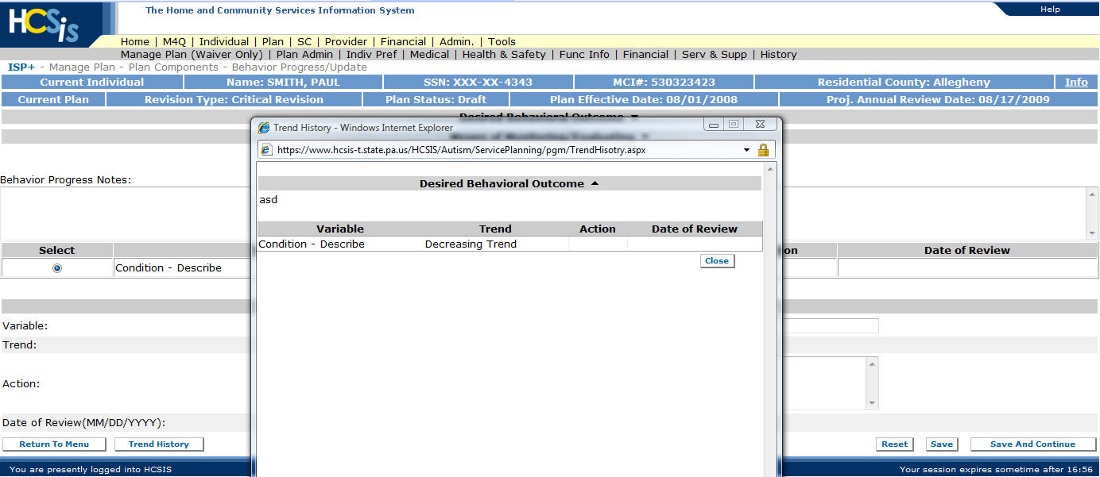
**In all HCSIS screens, it is imperative that the user remembers to click the "save and continue" button or the data entered will not be saved.

